

ASSET VERIFICATION AND RECORDING TOOL KIT


Plot 31, Bukoto Street
P.O Box 7657, Kampala, Uganda
+256 (0) 39 2000216/0772525235
email: cpa@cpa.ug

www.cpa.com

August to September 2026

VERIFICATION DETAILS

NAME OF THE REGION: | GREATER MASAKA
SUB-REGION:
Name of Local Government | LWENGO DISTRICT
VERIFIER PARTICULARS
Full name | NANTUMBWE PENINAH
Contact/ email and Telephone | 0704321431
Supervisor/ Sub team leader
Name | KALYOWA LAWRENCE
Contact | 0774106047
Date of submission

HEALTH CENTRES
INFORMANT INTERVIEW/DISCUSSION GUIDE (INCHARGE OR RESPONSIBLE PERSON)

Name of Health Centre:LWENGENYI HEALTH CENTRE III

1a | Does the Facility have a record of all assets provided under UgIFT.  (Obtain a record and verify if it has the costs and numbers supplied | Yes
1b | If Not ask how many were supplied and when.

2 | How does this facility Maintain (repair/service/replace) the assets provided under Ugift

They get funds from different organizations

3 | Does the facility take regular record about functionality/ or breakdown of the assets provided? | Yes

4 | How has the UgIFT support helped in service delivery in the area, any issues, challenges and any recommendations for better program implementation.

Upgrade the hospital, asset delivery

Challenges
- Solar is improper, its on and off
- Latrines fill up with water always
- They don’t have enough staff to help them at the facility
- They don’t have enough electricity to use on these equipments

PROCEED TO VERIFICATION AFTER THIS DISCUSSION

Recommendations

- Proper electricity is needed at the facility
- More staff are also needed
- Proper means of transport to help them at the facility.

Health centre checklist

NAME OF LG: LWENGO DISTRICT LOCAL GOVERNMENT NAME OF HEALTH FACILITY: LWENGENYI HEALTH CENTRE III

Equipment/ Item | Department | Asset Number | Item  Description | Life in Months | Tag Number ( engrave no.) | Date Of Purchase | Date Placed In Service | Recoverable cost | Cost | Acc Dep Cost | Net Book Value | Ytd Deprn | Equipment status | Remarks
B.P. Machine, Digital | OPD |  | Received 1 white in colour |  | Not engraved | 4/6/2025 | 5/6/2025 |  |  |  |  |  | Good condition | Functional
B.P. Machine (Aneroid wall mounted) | MOH |  | Received 1 white in colour with black metallic base |  | Not engraved | 4/6/2025 | 5/6/2025 |  |  |  |  |  | Good condition | Functional
Autoclave 20 Liters.,Duo Operated | MCH |  | It is 1 but not seen |  |  | 4/6/2025 | 5/6/2025 |  |  |  |  |  | Good condition | Functional
Bowl, Kick | MOH |  | It was 1 but not verified |  |  | 4/6/2025 | 5/6/2025 |  |  |  |  |  | Good condition | Functional
Bowl Stand | MOH |  | They were 2 but not seen. |  |  | 4/6/2025 | 5/6/2025 |  |  |  |  |  | Good condition | Functional
Counting chamber Neubauer- Improved | MOH |  | They were 2 but not verified. |  |  | 4/6/2025 | 5/6/2025 |  |  |  |  |  | Good condition | Functional
Cupboard Steel, Lockable |  |  | They received 3 grey in colour with compartments |  | Not engraved
Drip Stand | OPD |  | Received 8, it has 5 wheels with a straight vertical stand with locks |  | Not engraved | 4/6/2025 | 5/6/2025 |  |  |  |  |  | Good condition | Functional
ESR Stand | MOH |  | Received 1 but not verified |  |  | 4/6/2025 | 5/6/2025 |  |  |  |  |  | Good condition | Functional
Examination Couch | EMRGENCY |  | Received 1 with 4 silver stands with black soft sponge mattress with a lifter |  | Not engraved | 4/6/2025 | 5/6/2025 |  |  |  |  |  | Good condition | Functional
Examination light,LED | MOH |  | Not verified |  |  | 4/6/2025 | 5/6/2025 |  |  |  |  |  | Good condition | Functional
Glucometer | MOH |  | They were 2 white in colour with strip tin without a flicker |  | Not engraved | 4/6/2025 | 5/6/2025 |  |  |  |  |  | Good condition | Functional
Haemoglobin Meter, Digital | OPD |  | They received 2 white in colour with 3 buttons and a square screen |  | Not engraved | 4/6/2025 | 5/6/2025 |  |  |  |  |  | Good condition | Functional
Height Meter | MOH |  | It was 1 but not verified |  |  | 4/6/2025 | 5/6/2025 |  |  |  |  |  | Good condition | Functional
Instrument Trolley | YCC |  | They were 2 silver in colour and 4 black wheels |  | Not engraved | 4/6/2025 | 5/6/2025 |  |  |  |  |  | Good condition | Functional
Microscope Binocular | LAB |  | It was 1 white and black in colour |  | Not engraved | 4/6/2025 | 5/6/2025 |  |  |  |  |  | Good condition | Functional
Otoscope | OPD |  | Received 1 silver and black in colour |  | Not engraved | 4/6/2025 | 5/6/2025 |  |  |  |  |  | Good condition | Functional
Patient Screen | OPD |  | They received silver stand with a blue cross |  | Not engraved | 4/6/2025 | 5/6/2025 |  |  |  |  |  | Good condition | Functional
Patient Trolley | OPD |  | They received 1 with 4 wheels with a black soft mattress |  | Not engraved | 4/6/2025 | 5/6/2025 |  |  |  |  |  | Good condition | Functional
Refrigerator, Basic | MOH |  | It was 1 grey in colour |  | Not engraved | 4/6/2025 | 5/6/2025 |  |  |  |  |  | Good condition | Functional
Stethoscope | OPD |  | They received 4 black in colour with 2 rubber tubes |  | Not engraved | 4/6/2025 | 5/6/2025 |  |  |  |  |  | Good condition | Functional
Stop Watch | OPD |  | They received 2 but not seen |  |  | 4/6/2025 | 5/6/2025 |  |  |  |  |  | Good condition | Functional
Stretcher | OPD |  | They received 2 with 4 black wheels with a soft bed |  | Not engraved | 4/6/2025 | 5/6/2025 |  |  |  |  |  | Good condition | Functional
Stove, Gas | MOH |  | White in colour, 6 kilos stabex |  | Not engraved | 4/6/2025 | 5/6/2025 |  |  |  |  |  | Good condition | Functional
Weighing Scale with Height Meter, Adult | OPD |  | They received 2 white in colour with automated white and garage |  | Not engraved | 4/6/2025 | 5/6/2025 |  |  |  |  |  | Good condition | Functional
Weighing Scale, Infant | MOH |  | It was 1 but not seen |  |  | 4/6/2025 | 5/6/2025 |  |  |  |  |  | Good condition | Functional
Weighing Scale, Toddler | MOH |  | They 2 but not seen |  |  | 4/6/2025 | 5/6/2025 |  |  |  |  |  | Good condition | Functional
Wheel Chair | OPD |  | They received 3 with 4 wheels with 2 pads in black |  | Not engraved | 4/6/2025 | 5/6/2025 |  |  |  |  |  | Good condition | Functional
Audio Visual Equipment
Medical Waste Bin | OPD |  | They received 10 silver in colour wrapped with polythene bags |  | Not engraved | 4/6/2025 | 5/6/2025 |  |  |  |  |  | Good condition | Functional
Wall Clock | HEALTH |  | They received 4 round and white in colour with figures |  | Not engraved | 4/6/2025 | 5/6/2025 |  |  |  |  |  | Good condition | Functional
Diagnostic Equipment Set for MCH | MOH |  | Not verified |  |  | 4/6/2025 | 5/6/2025 |  |  |  |  |  | Good condition | Functional
Diagnostic Equipment Set for OPD | OPD |  | Not verified |  |  | 4/6/2025 | 5/6/2025 |  |  |  |  |  | Good condition | Functional
Glassware Set, Laboratory, Basic | LAB |  | Not verified |  |  | 4/6/2025 | 5/6/2025 |  |  |  |  |  | Good condition | Functional
Hollow Ware Set, Treatment | MOH |  | Not verified |  |  | 4/6/2025 | 5/6/2025 |  |  |  |  |  | Good condition | Functional
Instrument Set, Dressing | OPD |  | Not verified |  |  | 4/6/2025 | 5/6/2025 |  |  |  |  |  | Good condition | Functional
Instrument Set, Basic ENT | OPD |  | Not verified |  |  | 4/6/2025 | 5/6/2025 |  |  |  |  |  | Good condition | Functional
Instrument Set, Suture | OPD |  | Not verified |  |  | 4/6/2025 | 5/6/2025 |  |  |  |  |  | Good condition | Functional
Pulse Oximeter, Hand held | OPD |  | Not verified |  |  | 4/6/2025 | 5/6/2025 |  |  |  |  |  | Good condition | Functional
Bed, Adult Patient with Mattress | MOH |  | They received 20 beds silver in colour with a black soft mattress |  | Not engraved | 4/6/2025 | 5/6/2025 |  |  |  |  |  | Good condition | Functional
Bed, Pediatric Patient, With Mattress | 04 |  | They received 4 beds with white and black mattress. |  | Not engraved | 4/6/2025 | 5/6/2025 |  |  |  |  |  | Good condition | Functional
Bedside Locker | OPD |  | They received 10 lockers with 2 compartments |  | Not engraved | 4/6/2025 | 5/6/2025 |  |  |  |  |  | Good condition | Functional
Cupboard, Instrument | OPD |  | They were 5 but not verified |  |  | 4/6/2025 | 5/6/2025 |  |  |  |  |  | Good condition | Functional
Delivery Bed, Hydraulic Manual | MOH |  | It was 1 with a blue mattress with a drip |  | Not engraved | 4/6/2025 | 5/6/2025 |  |  |  |  |  | Good condition | Functional
Oxygen Therapy Apparatus, Mininum 45L cylinder | MOH |  | It was one but not verified |  |  | 4/6/2025 | 5/6/2025 |  |  |  |  |  | Good condition | Functional
Resuscitator Manual, Infant, with all Mask sizes | MOH |  | It was 1 but not verified |  |  | 4/6/2025 | 5/6/2025 |  |  |  |  |  | Good condition | Functional
Resuscitator Manual, Adult, with all mask sizes | MOH |  | They were 2 but not verified |  |  | 4/6/2025 | 5/6/2025 |  |  |  |  |  | Good condition | Functional
Suction Apparatus, (Electric) | MOH |  | It was one with 2 white bags of water |  | Not engraved | 4/6/2025 | 5/6/2025 |  |  |  |  |  | Good condition | Functional
Nebulizer, Ultrasonic | MOH |  | It was 1 but not seen |  |  | 4/6/2025 | 5/6/2025 |  |  |  |  |  | Good condition | Functional
Oxygen Concentrator, Duo Flow | MOH |  | It was 1 with grey 2 handles on top and cylinder also on top |  | Not engraved | 4/6/2025 | 5/6/2025 |  |  |  |  |  | Good condition | Functional
Bench | OPD |  | They were 4 with brown soft sponge with brown wooden stands |  |  | 4/6/2025 | 5/6/2025 |  |  |  |  |  | Good condition | Functional
Disinfection Buckets | MOH |  | They were 4 normal buckets with different colours |  | Not engraved | 4/6/2025 | 5/6/2025 |  |  |  |  |  | Good condition | Functional
Baby Cot | OPD |  | They were 2 silver in colour, rectangular with rails |  | Not engraved | 4/6/2025 | 5/6/2025 |  |  |  |  |  | Good condition | Functional
Diagnostic Equipment Set for Ward | MOH |  | It was 1 but not seen |  |  | 4/6/2025 | 5/6/2025 |  |  |  |  |  | Good condition | Functional
Hollow Ware Set, Ward | MOH |  | They were 2 but not verified. |  |  | 4/6/2025 | 5/6/2025 |  |  |  |  |  | Good condition | Functional
Instrument Set, Delivery | MOH |  | They were 2 but not verified. |  |  | 4/6/2025 | 5/6/2025 |  |  |  |  |  | Good condition | Functional
Instrument Set, Stitch Removing | MOH |  | It was 1 but not verified. |  |  | 4/6/2025 | 5/6/2025 |  |  |  |  |  | Good condition | Functional
MVA Kit | MOH |  | They were 4 but not verified |  |  | 4/6/2025 | 5/6/2025 |  |  |  |  |  | Good condition | Functional
Stool, Laboratory | LAB |  | It was 1 black in colour |  | Not engraved | 4/6/2025 | 5/6/2025 |  |  |  |  |  | Good condition | Functional
Penguin Sucker | OPD |  | They were 3 rubber in nature |  |  | 4/6/2025 | 5/6/2025 |  |  |  |  |  | Good condition | Functional
Fetoscope, Dopplar | OPD |  | It was 1 silver in nature, cylindrical with a round top on base |  | Not engraved | 4/6/2025 | 5/6/2025 |  |  |  |  |  | Good condition | Functional
Bubble CPAP
Centrifuge (Electric) | MOH |  | It was one but not seen |  |  | 4/6/2025 | 5/6/2025 |  |  |  |  |  | Good condition | Functional
Kangaroo Mother Care Chair | MOH |  | It was 1 with four wheels with a brown soft sponge |  | Not engraved | 4/6/2025 | 5/6/2025 |  |  |  |  |  | Good condition | Functional
Radiant Infant Warmer | MOH |  | They were 2 but not seen |  |  | 4/6/2025 | 5/6/2025 |  |  |  |  |  | Good condition | Functional
Haemoglobin Meter, Sahli | MOH |  | They were 2 but not seen |  |  | 4/6/2025 | 5/6/2025 |  |  |  |  |  | Good condition | Functional
Delivery Bed | MOH |  | It was 1 with a black mattress |  | Not engraved | 4/6/2025 | 5/6/2025 |  |  |  |  |  | Good condition | Functional
Examination light | OPD |  | They were 2 with a bulb on top with 5 wheels |  | Not engraved | 4/6/2025 | 5/6/2025 |  |  |  |  |  | Good condition | Functional
Instrument set, ENT Basic for HCIII | MOH |  | It was but not verified |  |  | 4/6/2025 | 5/6/2025 |  |  |  |  |  | Good condition | Functional
Bag Valve mask (Ambu Bag), Neonatal | MOH |  | They were 14 with white yellow valve and a glass with white masks |  | Not engraved | 4/6/2025 | 5/6/2025 |  |  |  |  |  | Good condition | Functional
Incubator
Office Chair | OFFICE |  | They were 7 black in colour swinging in nature |  | Not engraved | 4/6/2025 | 5/6/2025 |  |  |  |  |  | Good condition | Functional
Desk | OPD |  | They were 5 brown in colour |  | Not engraved | 4/6/2025 | 5/6/2025 |  |  |  |  |  | Good condition | Functional
Filing Cabinet | OPD |  | They were 2 but not verified. |  |  | 4/6/2025 | 5/6/2025 |  |  |  |  |  | Good condition | Functional
Non Residential Buildings
Residential Buildings | STAFFS |  | They were 2 rooms in one block |  | Not verified | 4/6/2025 | 5/6/2025 |  |  |  |  |  | Good condition | Functional

Reception and signpost Toilets and reception Delivery bed
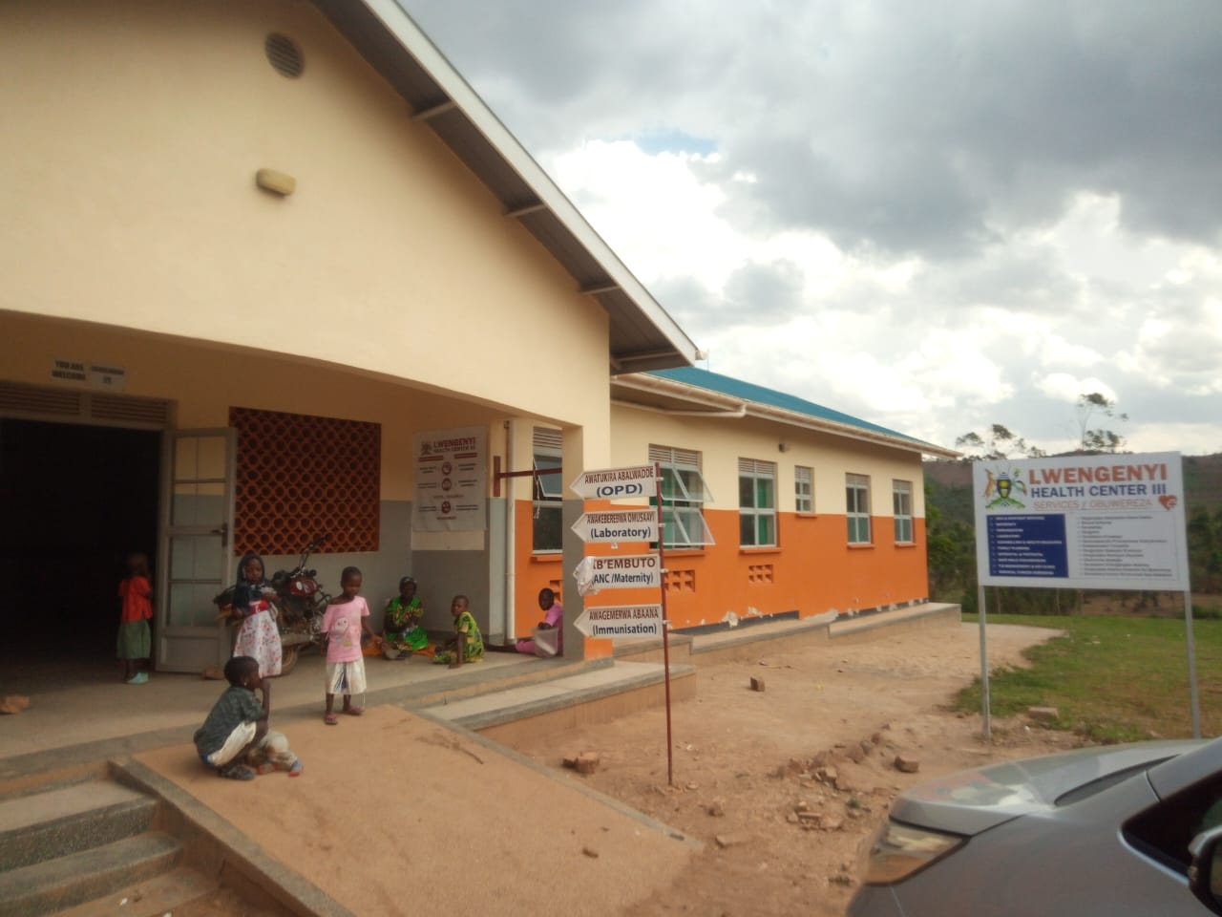
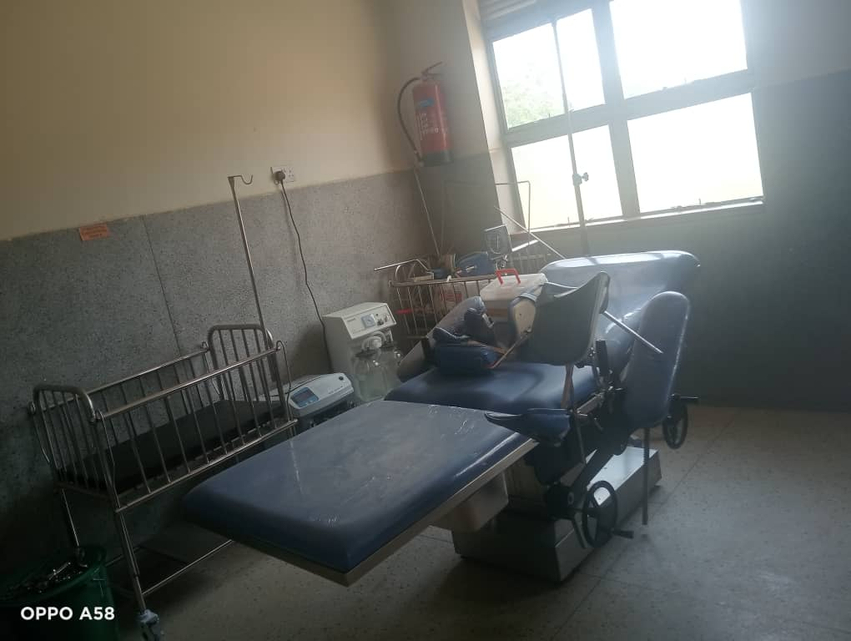
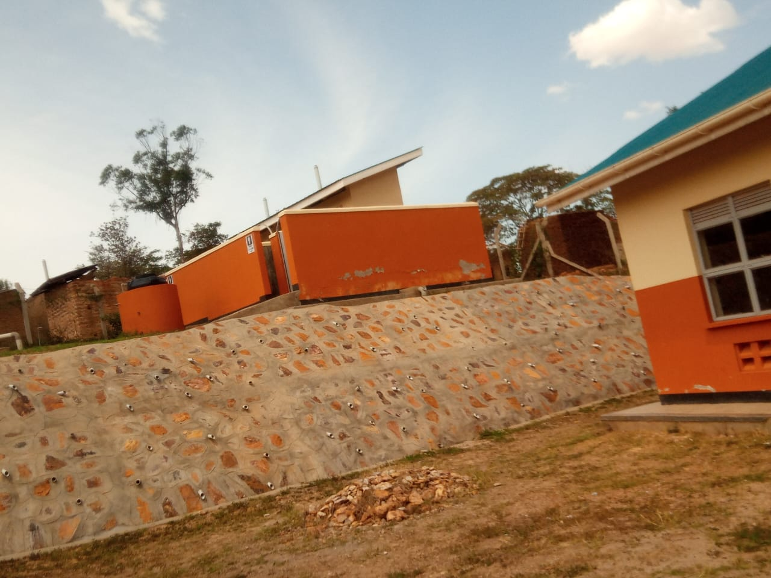

laboratory Fridge
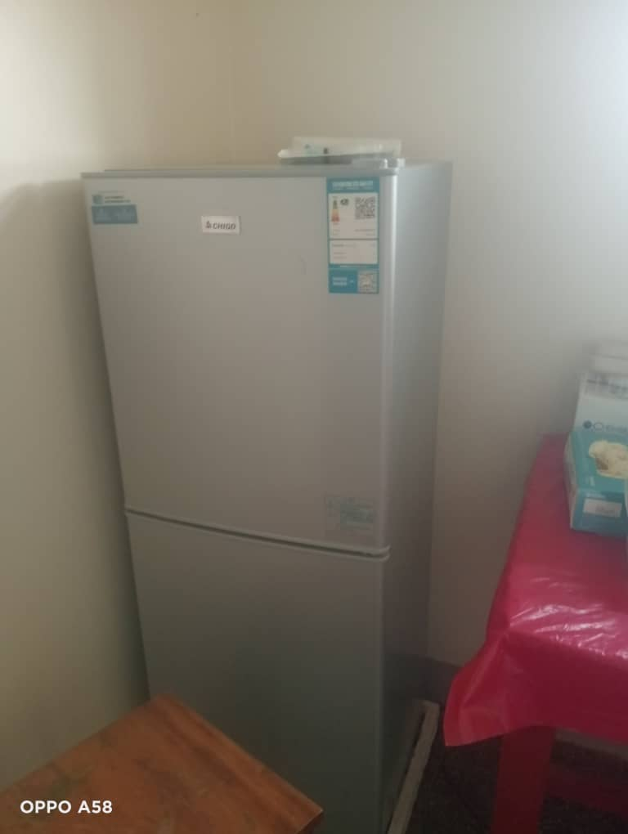
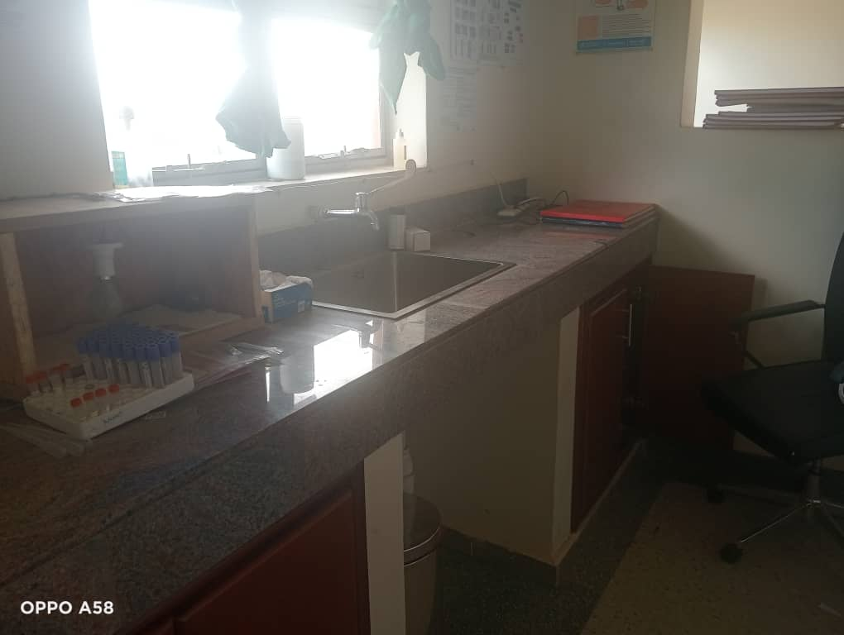

SCHOOL VERIFICATION CHECKLIST

SCHOOL INTERVIEW/DISCUSSION GUIDE

Name of school: KATOVU SEED SECONDARY SCHOOL

1a | Does the Facility have a record of all assets provided under UgIFT.  (Obtain a record and verify if it has the costs and numbers supplied | Yes
1b | If Not ask how many were supplied and when.

2 | How does this facility Maintain (repair/service/replace) the assets provided under Ugift

They get funds from different organizations

3 | Does the facility take regular record about functionality/ or breakdown of the assets provided?  Nonfunctional/ working, and reasons for non-functionality. | Yes

4 | How has the UgIFT support helped in service delivery in the area, any issues, challenges and any recommendations for better program implementation.

Benefits
- Job creation and education opportunities.

Challenges
- The buildings are small compared to the population
- They pay little money as salary
- Ugift should follow up on ground especially asset distribution
- Inadequate teachers and under payment of non-teaching staff.
- Too small staff quarters built.

PROCEED TO VERIFICATION AFTER THIS DISCUSSION

Recommendations
- They need more classroom blocks
- They need more supervisors who full in charge
- They need more staffs
- They need more salary allowances

SCHOOL FURNITURE
(School Desks, Office chairs, Laboratory stools, Book shelves)

Name of LG: LWENGO DISTRICT LOCAL GOVERNMENT Name of SCHOOL: KATOVU SEED SECONDARY SCHOOL

Equipment/ Item | Department | Asset Number | Item  Description | Life in Months | Tag Number ( engrave no.) | Date Of Pur | Date Placed In Service | Recoverable cost | Cost | Acc Dep Cost | Net Book Value | Ytd Deprn | Equipment status | Remarks
Stools | Lab | 100 | They received 100 brown wooden seats with a black metal stand |  | Not engraved | 2/12/2025 | 3/12/2025 |  |  |  |  |  | Good in use | Functional
Desks | Classroom | 120 | They received 120 brown wooden seats with a black mettallc stand |  | Not engraved | 2/12/2025 | 3/12/2025 |  |  |  |  |  | Good in use | Functional
Noticeboard | Education | 50 | they received 50 with a hard book cover design |  | Not engraved | 2/12/2025 | 3/12/2025 |  |  |  |  |  | Good in use | Functional
Tables | Education | 125 | They received 125 in brown colour |  | Not engraved | 2/12/2025 | 3/12/2025 |  |  |  |  |  | Good in use | Functional
Shelves | Education | 39 | They received 39 brown in colour |  | Not engraved | 2/12/2025 | 3/12/2025 |  |  |  |  |  | Good in use | Functional
Office chairs | Education | 20 | They received 20 brown n colour with a soft sponge |  | Not engraved | 2/12/2025 | 3/12/2025 |  |  |  |  |  | Good in use | Functional

ICT ITEMS TO VERIFY
(Desktop Computer, Server Processor, Network Switch 24 Port, Multipurpose Printer, UPS, Projector, Air Conditioners, Server, CCTV Camera)

Name of LG: LWENGO DISTRICT LOCAL GOVERNMENT Name of SCHOOL: KATOVU SEED SECONDARY SCHOOL

Equipment/ Item | Department | Asset Number | Item  Description | Life in Months | Tag Number ( engrave no.) | Date Of Pur | Date Placed In Service | Recoverable cost | Cost | Acc Dep Cost | Net Book Value | Ytd Deprn | Equipment status | Remarks
Printer | Education | 01 | Received  1 but not  Verified |  |  | 24/8/2025 | 23/8/2025 |  |  |  |  |  | Good in use | Functional but bad
Air conditioner | Education | 04 | They received  4 but not  verified |  |  | 24/8/2025 | 23/8/2025 |  |  |  |  |  | Good in use | Functional
CCTV | Education | 01 | Received 1  But not verified |  |  | 24/8/2025 | 23/8/2025 |  |  |  |  |  | Good in use | Functional
UPS | Education | 28 | Received 28  But not  verified |  |  | 24/8/2025 | 23/8/2025 |  |  |  |  |  | Good in use | Functional
Desktop | Education | 28 | Received 28  Black in colour  With all its  things |  | Not  engraved | 24/8/2025 | 23/8/2025 |  |  |  |  |  | Good in use | Functional

BUILDINGS TO VERIFY
(Non- Residential and Residential, Kitchen, Toilets/Pit latrine Water tanks, Fences etc.)

Name of LG; LWENGO DISTRICT Name of SCHOOL: KATOVU SEED SECONDARY SCHOOL

Equipment/ Item | Department | Asset Number | Item  Description | Life in Months | Tag Number ( engrave no.) | Date Of Pur | Date Placed In Service | Recoverable cost | Cost | Acc Dep Cost | Net Book Value | Ytd Deprn | Equipment status | Remarks
Play ground | Education | 01 | 1 pitch big and large |  | Not engraved | 2/12/25 | 1/1/26 |  |  |  |  |  | Good in use | Functional
Tanks | Education | 03 | They are 3 black in colour covered with hard cement |  | Not engraved | 2/12/25 | 1/1/26 |  |  |  |  |  | Good in use | Functional
Classroom block | Education | 03 | They are 3 blocks 2 classrooms each |  | Not engraved | 2/12/25 | 1/1/26 |  |  |  |  |  | Good in use | Functional
Administrative block | Education | 01 | It has 1 block with office and staffroom |  | Not engraved | 2/12/25 | 1/1/26 |  |  |  |  |  | Good in use | Functional
ICT/Library blocks | Education | 01 | It is 1 block shared with ICT and library |  | Not engraved | 2/12/25 | 1/1/26 |  |  |  |  |  | Good in use | Functional
Lab block | Education | 01 | It is 1 block shared with science subject |  | Not engraved | 2/12/25 | 1/1/26 |  |  |  |  |  | Good in use | Functional
Toilet | Education | 06 | It has 6 blocks with 2 each rooms |  | Not engraved | 2/12/25 | 1/1/26 |  |  |  |  |  | Good in use | Functional
Main hall | Education | 01 | It is 1 block for mainhall |  | Not engraved | 2/12/25 | 1/1/26 |  |  |  |  |  | Good in use | Functional
Staff quarter | Education | 03 | They are 3 blocks 2 rooms each |  | Not engraved | 2/12/25 | 1/1/26 |  |  |  |  |  | Good in use | Functional

Field Class block Administration block
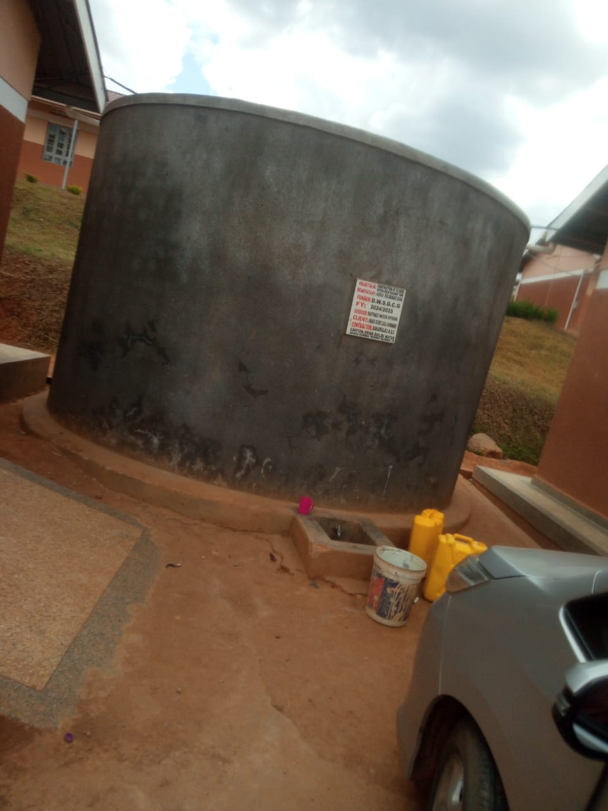
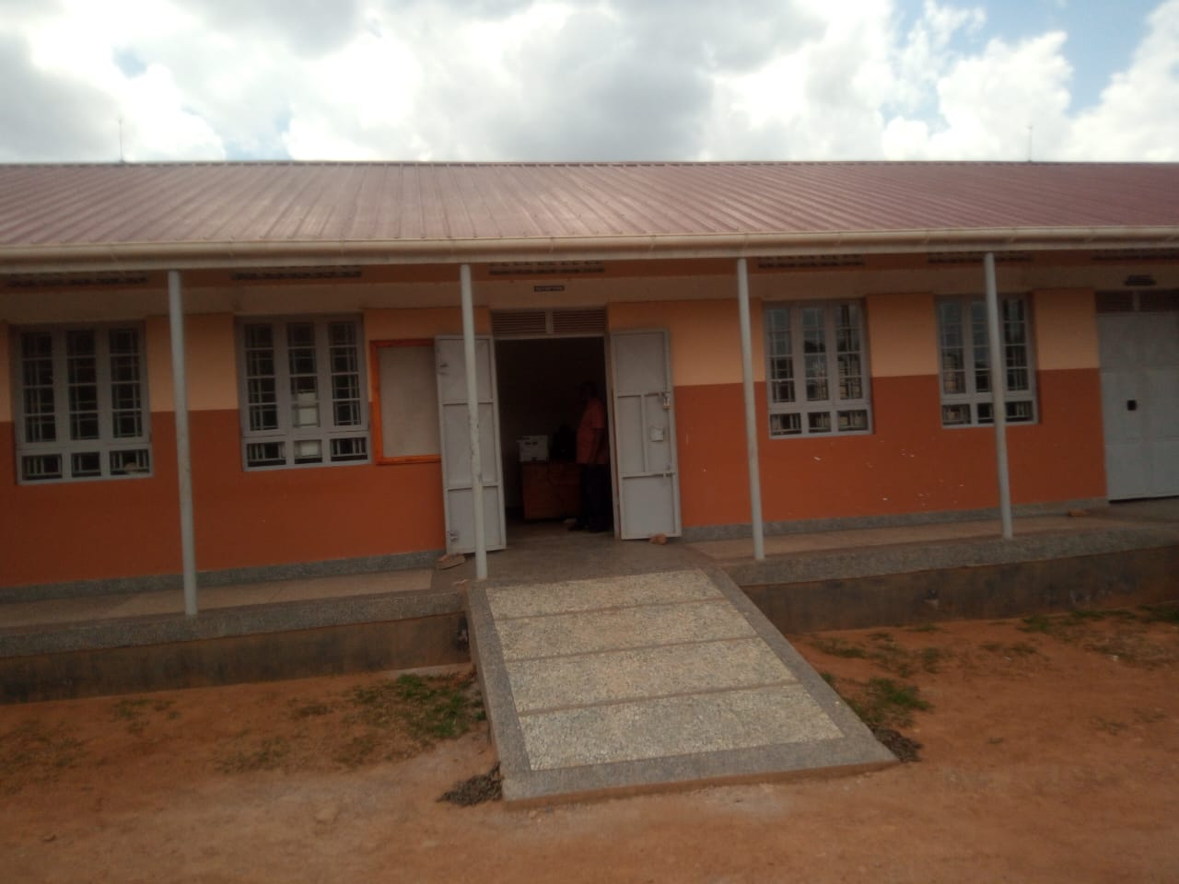
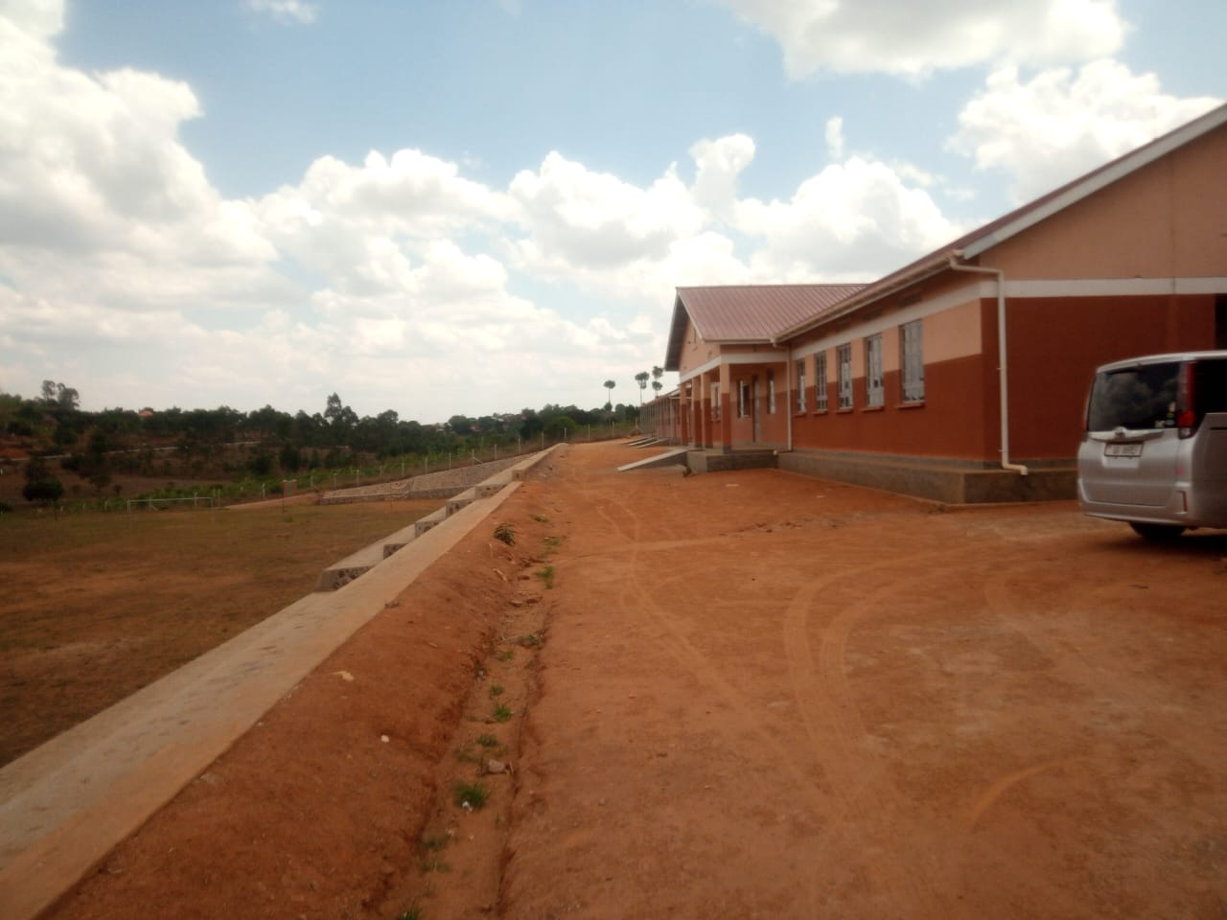
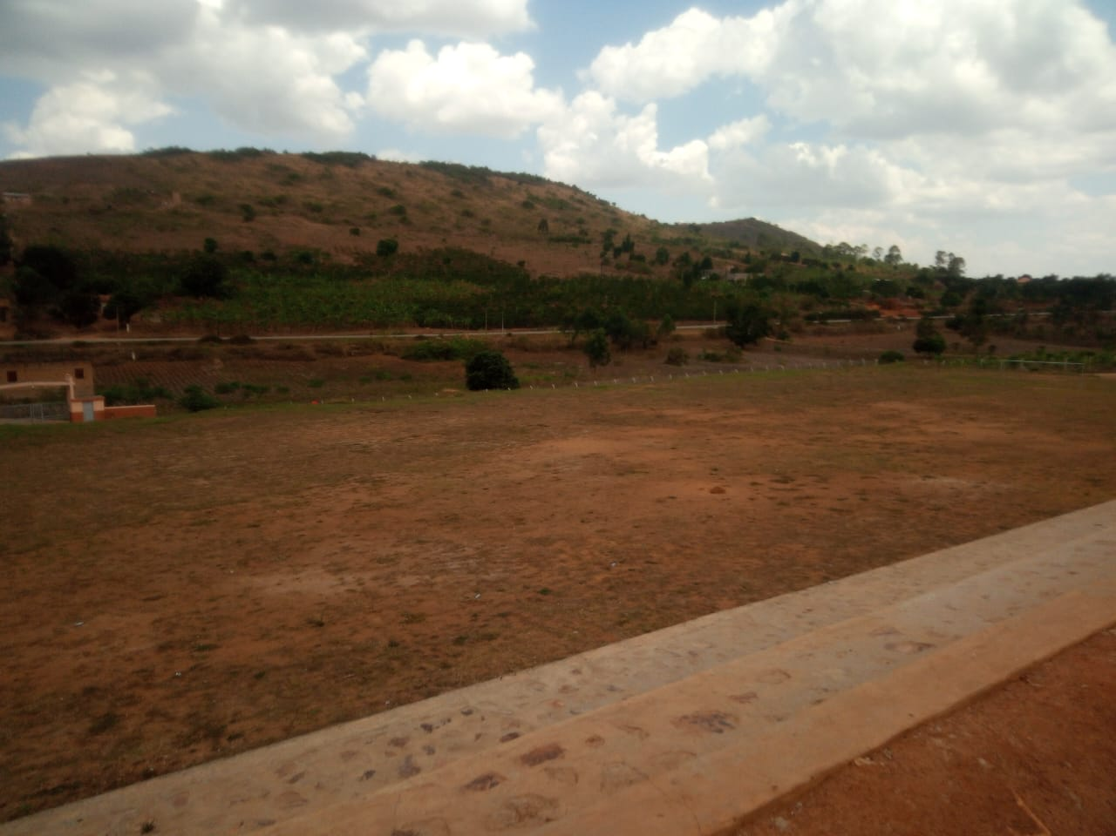

Tank

